

Senior Design Project

ECE 595

Weekly Journal

Shaima Hussien

Table of Contents

Week (4-5) Feb 10th: 3

Goals of the week: 3

General Notes: 3

Results and Conclusions: 6

Next Step: 6

Week (6-7) Feb 28th: 6

Goals of the week: 6

General Notes: 6

Results and Conclusions: 10

Next Step: 10

**Weekly Journal:**

# **Week (4-5) Feb 10th:**

# **Goals of the week:**

* Learn about open CV that will be used for face detection.
* install open CV
* Calculate how much power is needed to run the product.
* Try to connect the thermal camera to raspberry pi.

# **General Notes:**

Open CV or as it known as computer vision is an open-source library for the computer vision machine learning and image processing that it can be used to identify different object and even faces.

First step is install Open cv on my computer:

1- install Home brew which is open-source software package management system that simplifies the installation of software on Apple's operating system, macOS

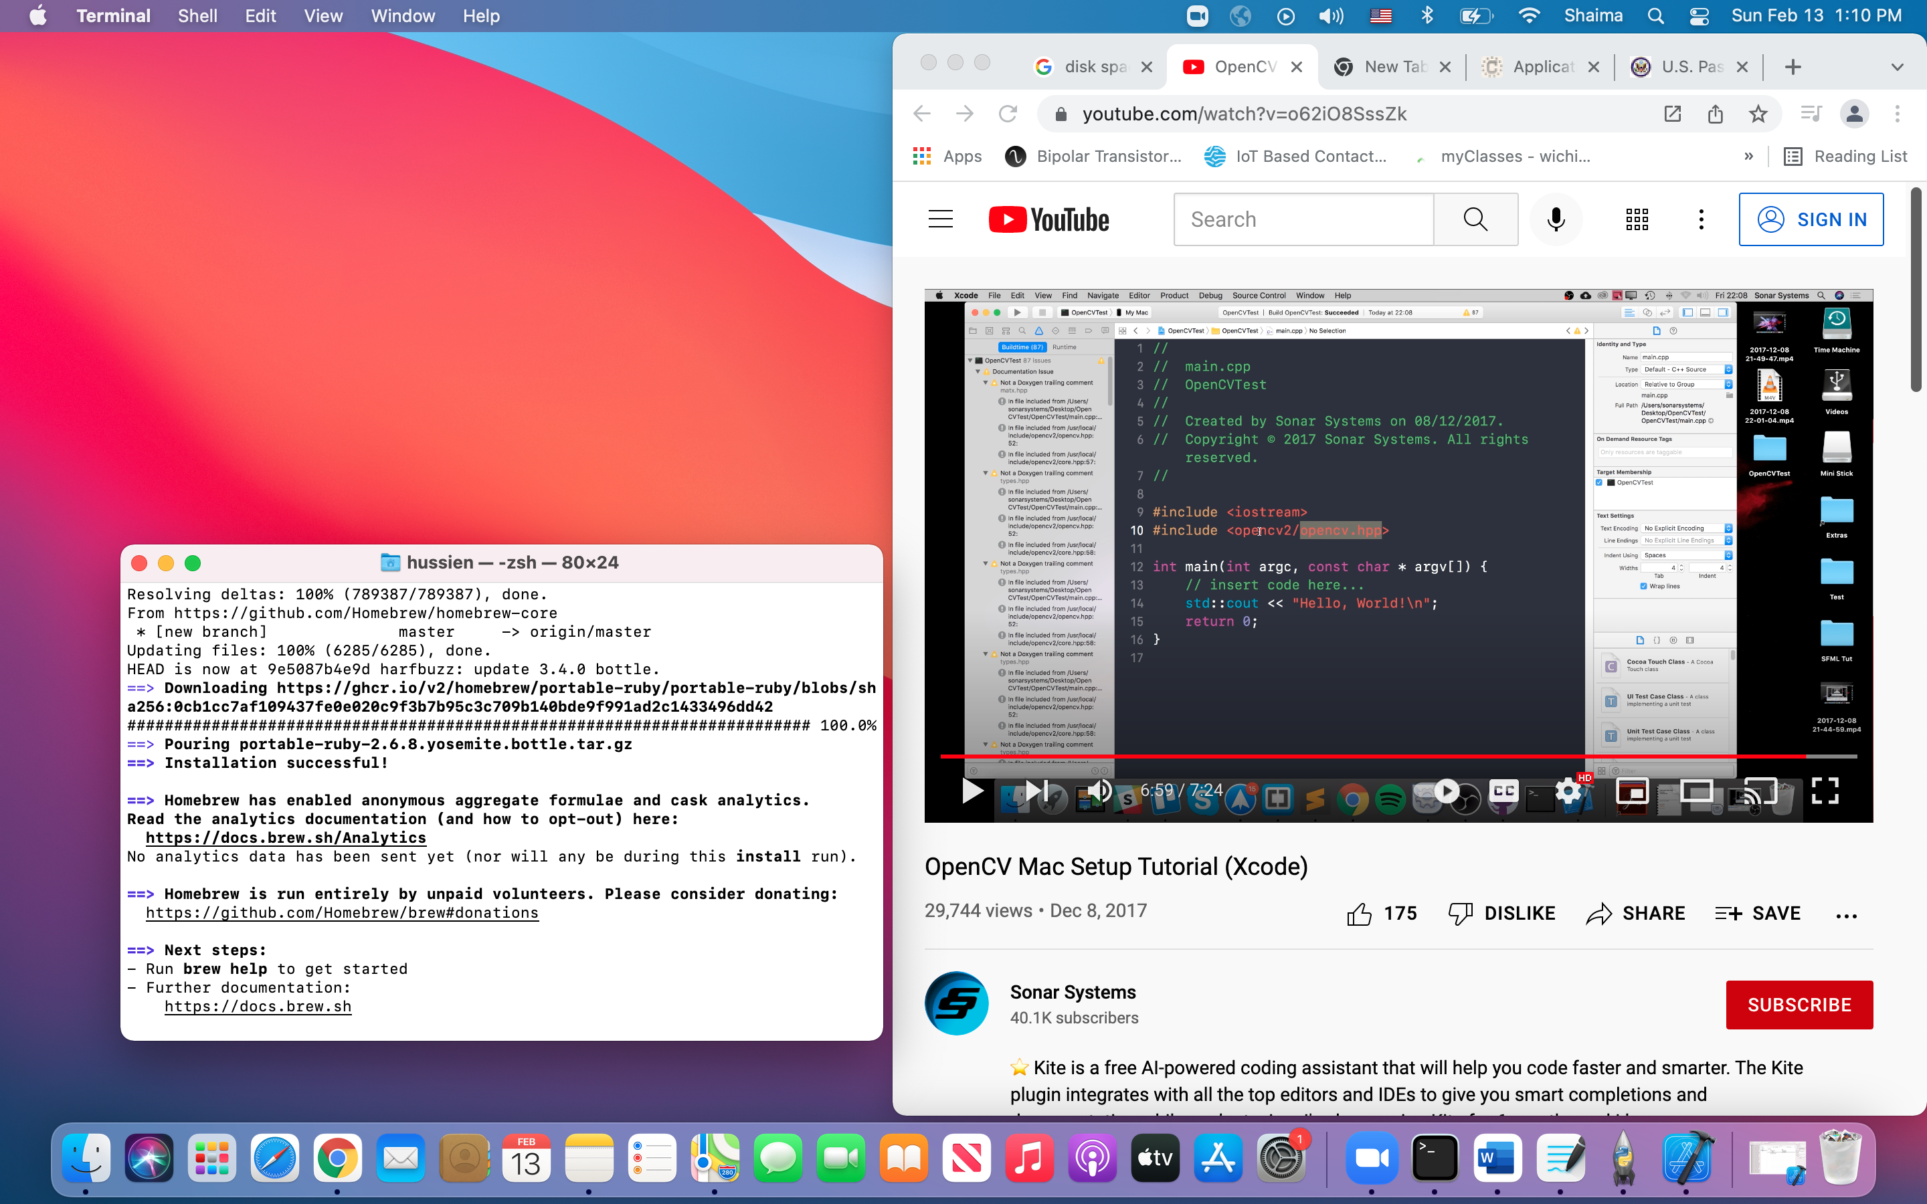

2- Install open cv

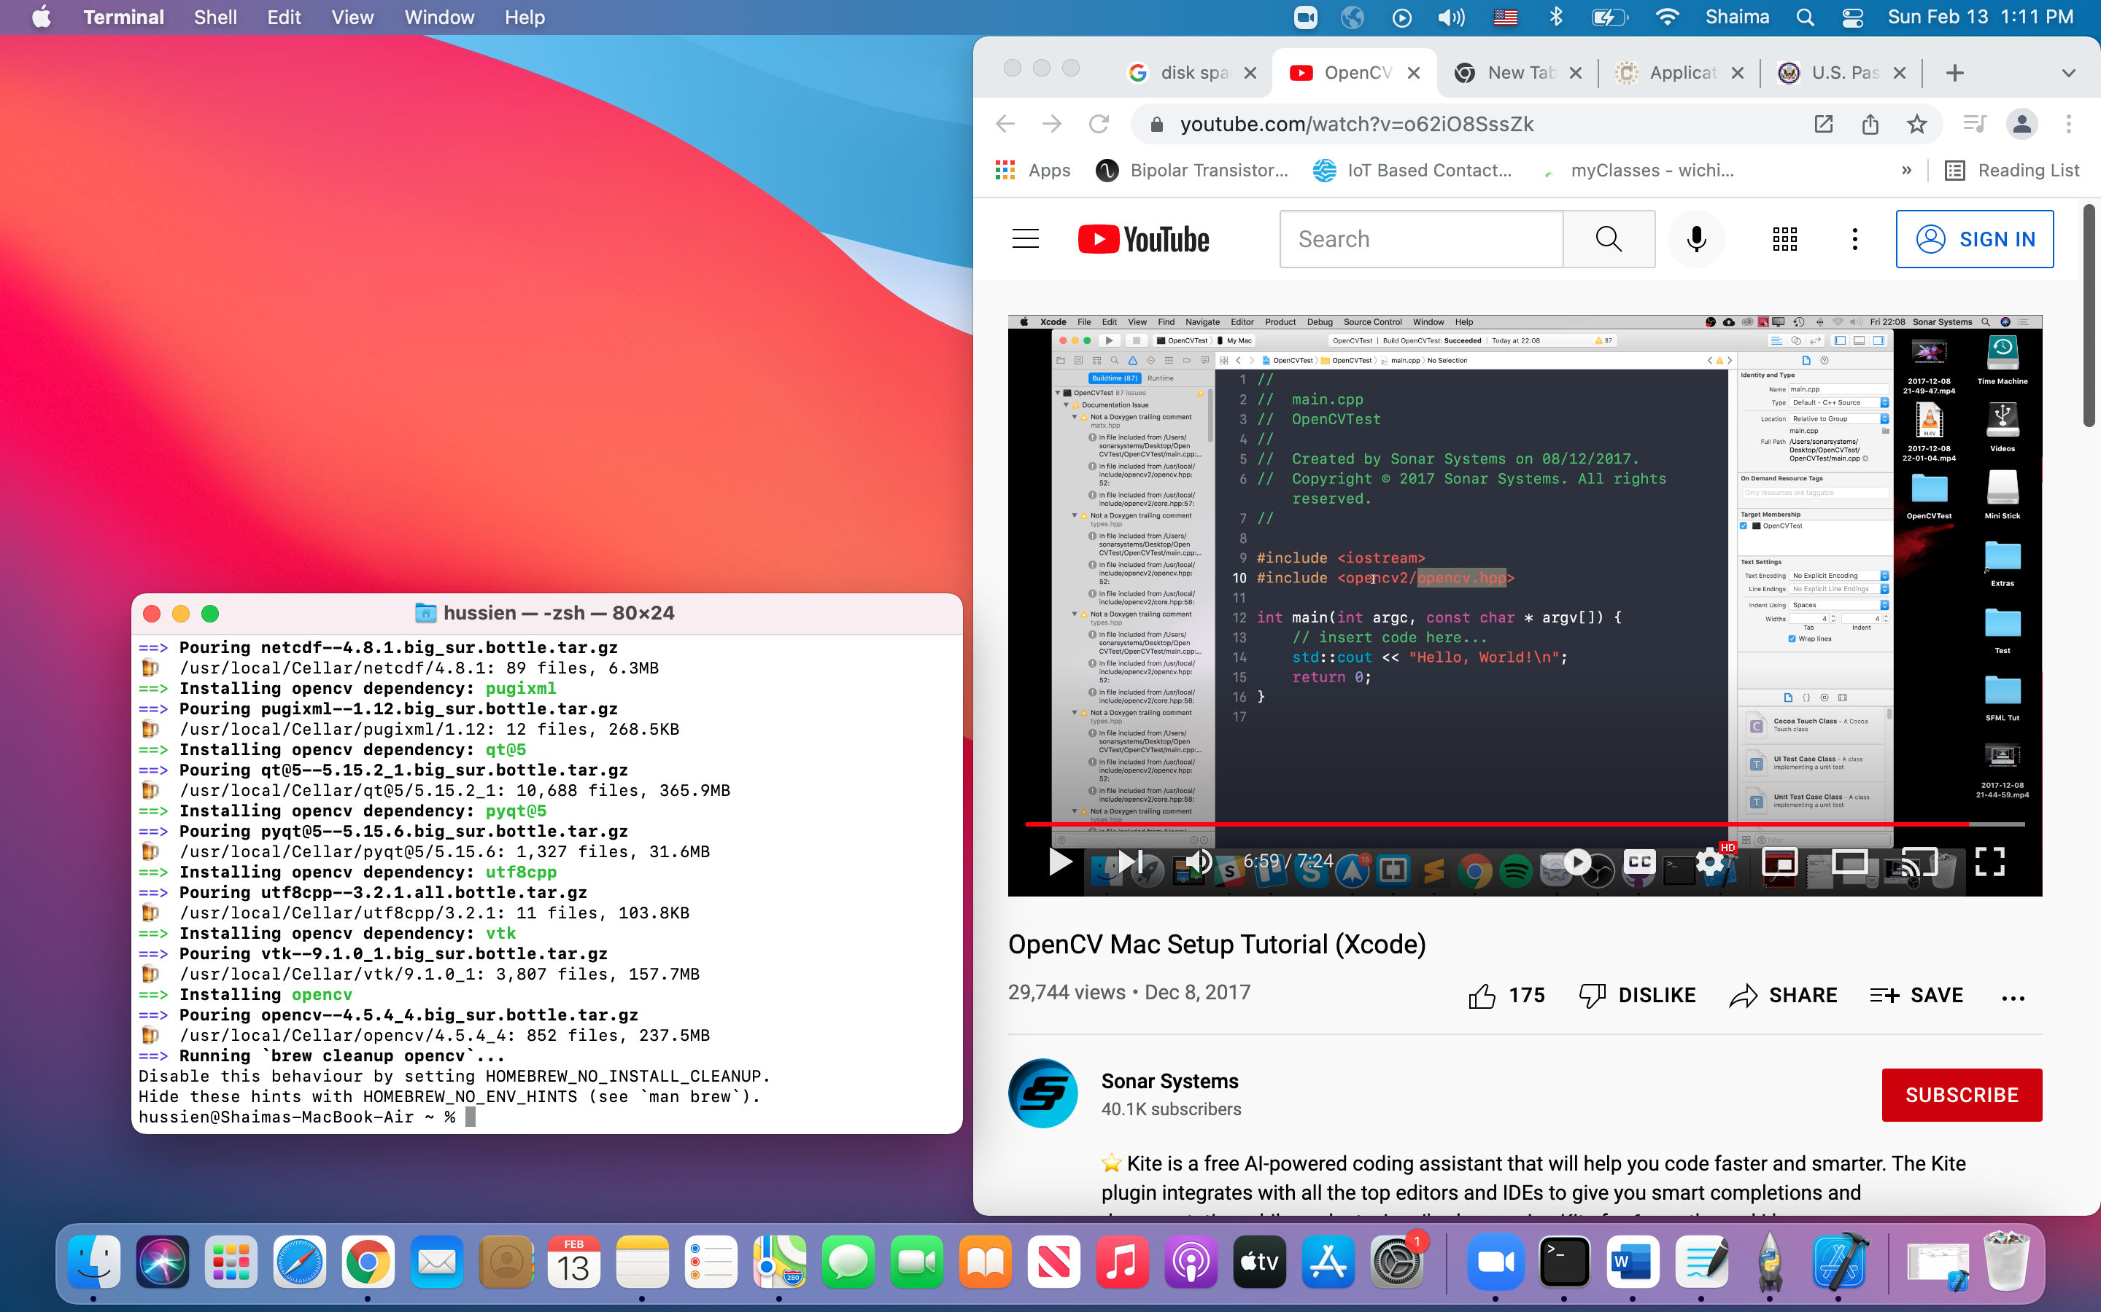

I am trying to connect the thermal camera on raspberry pi to measure the temperatures the issue I have is my raspberry pi is not picking the address of the thermal camera.

1- I sorted 5 pins on HDMI screen to plug the thermal camera.

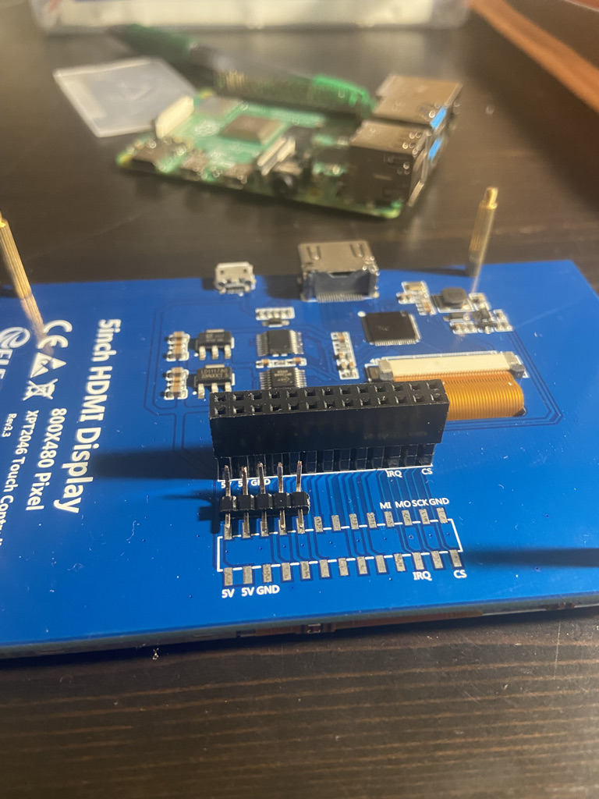

2- Attached the raspberry 4 on HDMI by using HDMI bridge and the thermal camera.

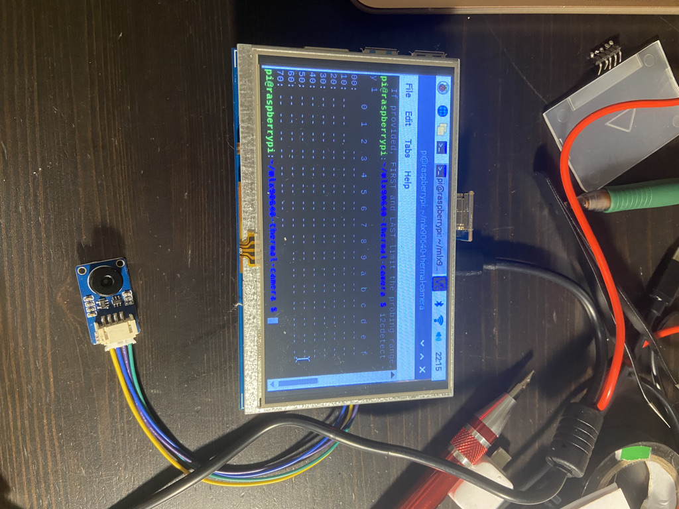

# **Results and Conclusions:**

Raspberry pi is not picking the right address for the thermal camera

# **Next Step:**

-Continue working on the raspberry pi and thermal camera.

-Set up Open CV.

# **Week (6-7) Feb 28th:**

# **Goals of the week:**

* Connect the thermal camera to the Raspberry pi.
* Figure out the right address for the Pi.
* Install the needed libraries on python to run the thermal camera.
* Understand what each pin of the pi is

# **General Notes:**

Some of the challenges I had to deal with was to connect the thermal camera to the pi correctly and make sure that it is picking the right address, the root cause of this problem was not connecting the pi the 5-inch HDMI lcd correctly.

to expand my knowledge about our product, I needed to understand what each pin is corresponded to in the pi.

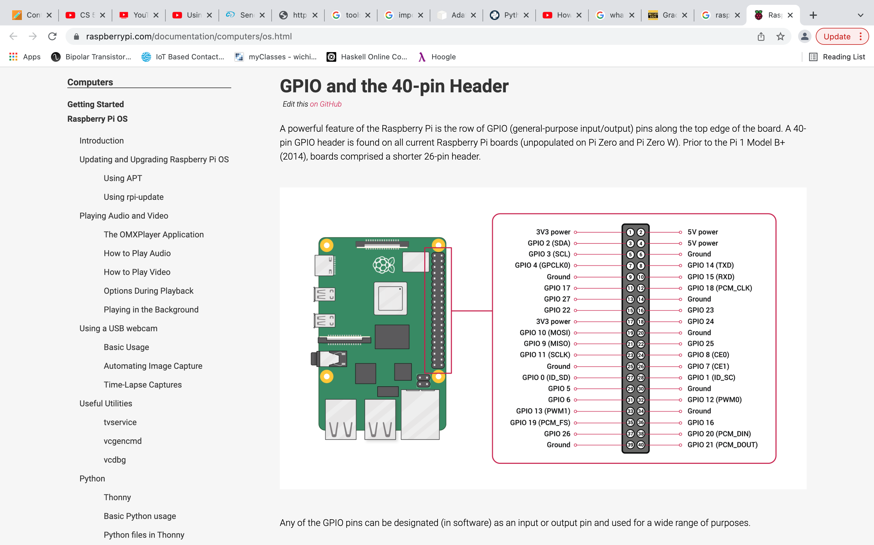

Source 🡪 <https://www.raspberrypi.com/documentation/computers/os.html>

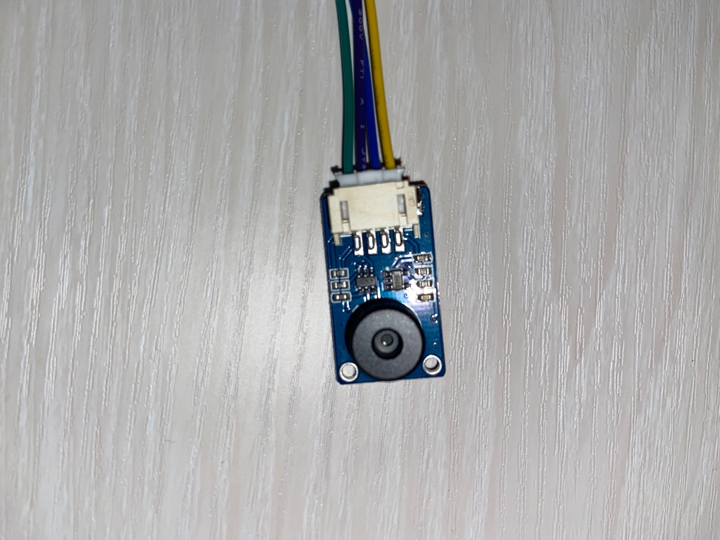 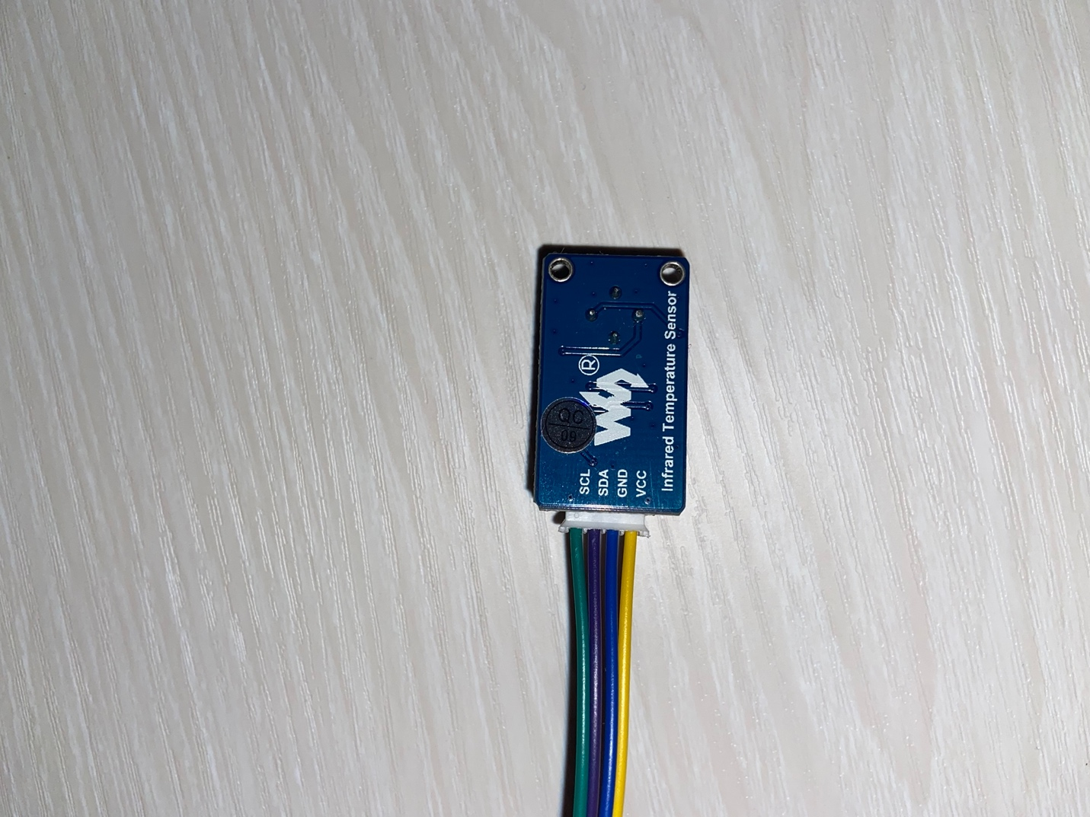

**Integration between Raspberry Pi and Adafruit MLX90640:**

The pin out connections from the Adafruit MLX90640 are straightforward. For this project only 4 pins will be used:

* **Vin** 🡪It is the power pin. The Adafruit sensor uses 3.3V it will be connected to corresponding 3.3V pin which is pin 1 on the Raspberry Pi
* **GND** 🡪 this is common ground for power and logic. I connect it to ground pin (pin 9) on

the Pi4. There are more than 1 ground pin on the Pi4.

* **SCL** 🡪this is the I2C clock pin, and it will be connected it to the corresponding SCL pin on the Pi4 which is pin 5.
* **SDA** 🡪this is the I2C data pin, and it will be connected it to the corresponding SDA pin on the Pi4, which is pin 3.

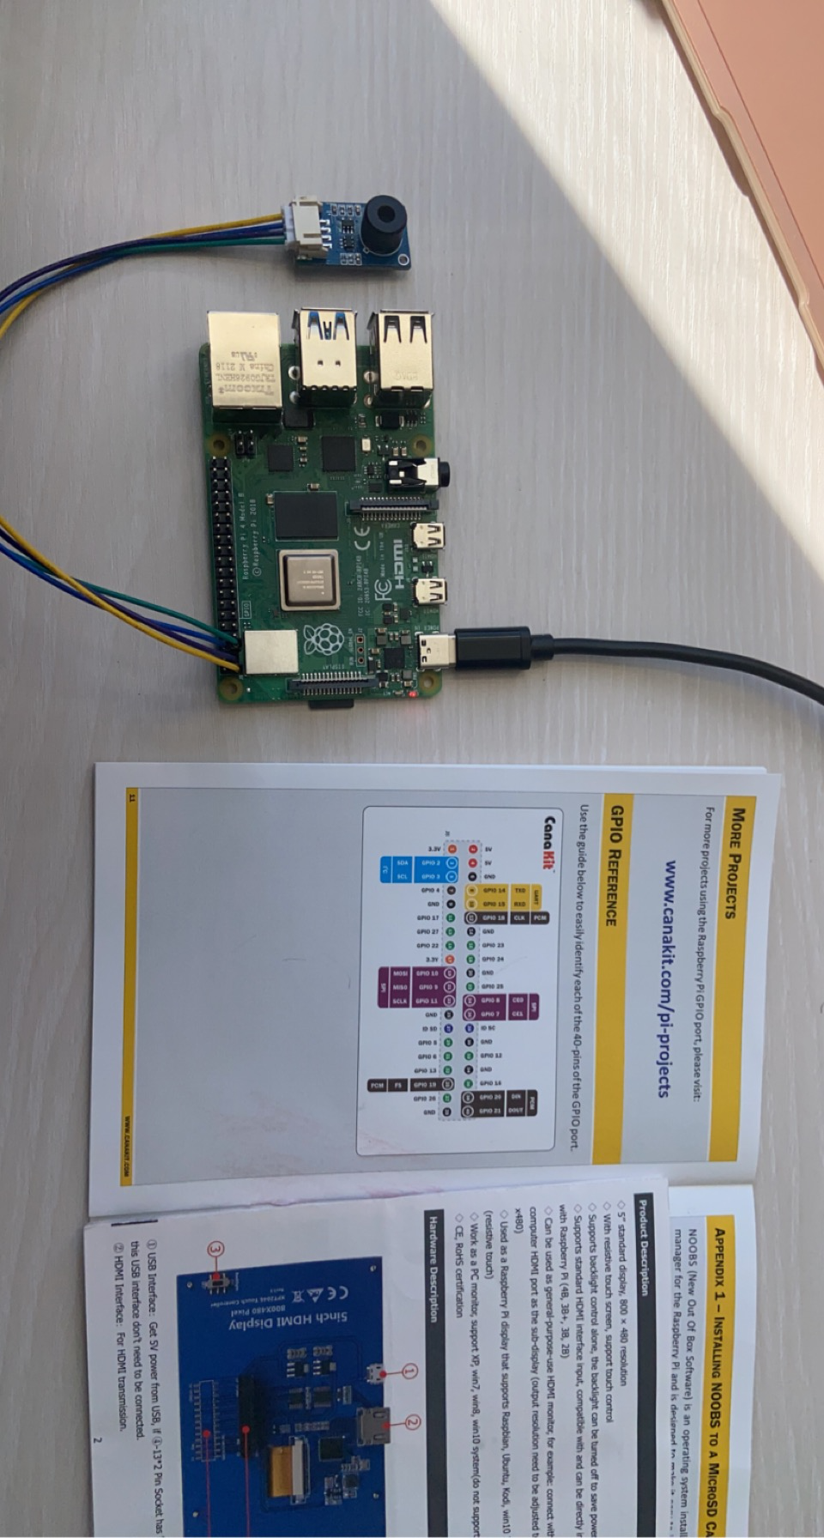

after connect the thermal camera to the right pins on the pi and install the i2c library .. finally I can see that the it getting an address.

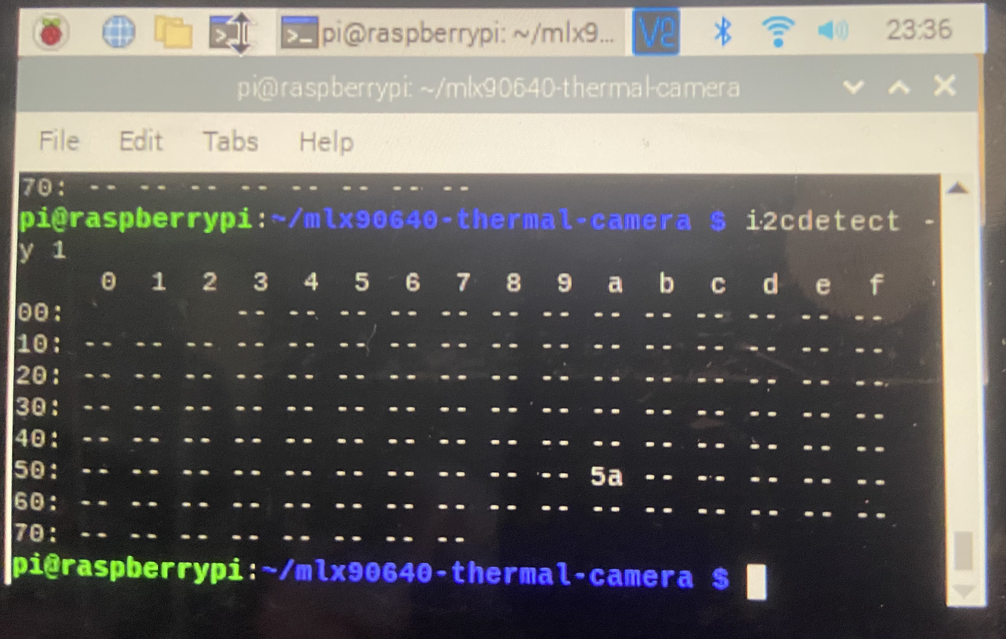

now it’s the time to run the code[. https://tutorial.cytron.io/2020/12/09/send-data-to-firebase-using-raspberry-pi/](https://tutorial.cytron.io/2020/12/09/send-data-to-firebase-using-raspberry-pi/)

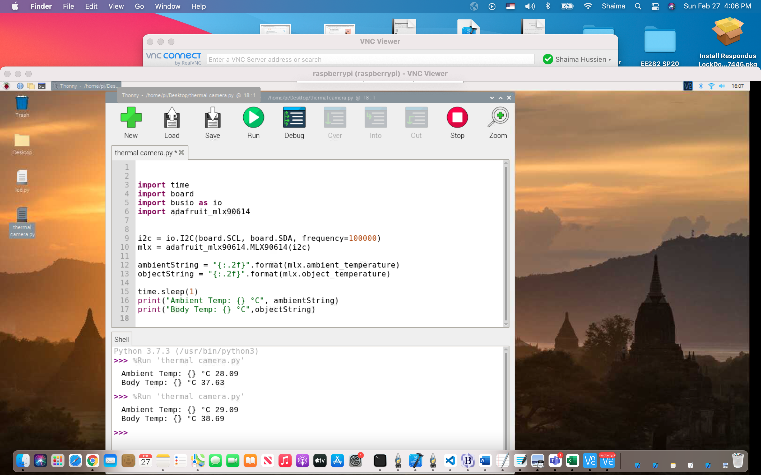

# **Results and Conclusions:**

So now the thermal camera can detect a body temperature and ambient temperature.

# **Next Step:**

-Continue working on open cv.

-Develop some python skills.

-Work on the calculations and calculate how much power needed to run the whole unit.